React-Native Day1

- Create your First reactnative app
- Make a screen with this UI:
  - The all categories section Scroll Horizontally and make the item touchableOpacity.
  - Open Restaurant section scroll Vertically .

- 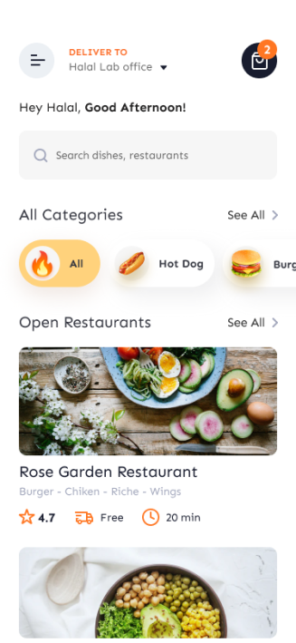

Bonus:---------------

